Task 2 File Permission Task

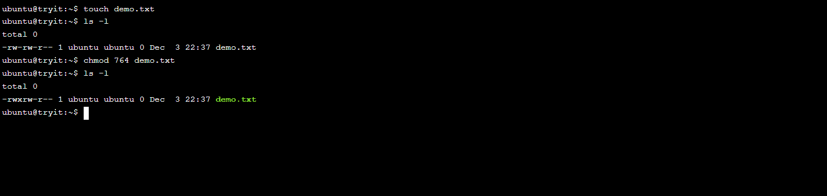

https://docs.google.com/document/d/1nmbC9-RJLwcEViPgsntaU3rHiJMneDfXsEOyYqw0Z1c/edit?tab=t.0